Lesson 25: Alarm of Fire

1.Flame sensor:
Flame sensor is generally divided into far-infrared flame sensor and ultraviolet flame sensor, and its working principle is to detect the heat radiation of fire source of specific wavelength. The far-infrared flame sensor can detect infrared light with a wavelength in the range of 700 nanometers to 1000 nanometers, and the detection angle is 60. When the infrared light wavelength is around 880 nanometers, its sensitivity reaches the maximum. The far-infrared flame probe converts the change of the intensity of the external infrared light into the change of the current, which is reflected as the change of the value in the range of 0~65535 through the A/D converter.
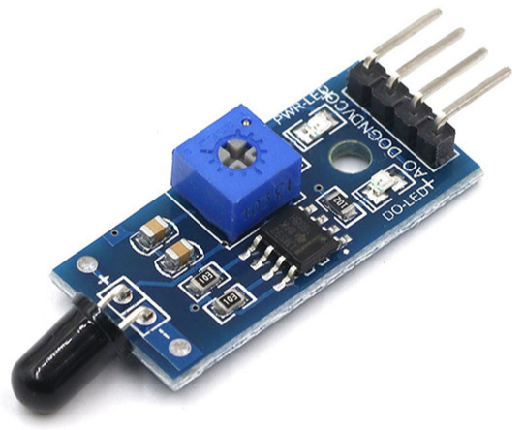

2.Project Introduction:
Simulate a fire alarm system, judge whether a fire occurs by judging whether the induction probe of the flame sensor detects the fire source, control the RGB lights to flash red and blue, and display the alarm information on the LCD1602 liquid crystal screen.
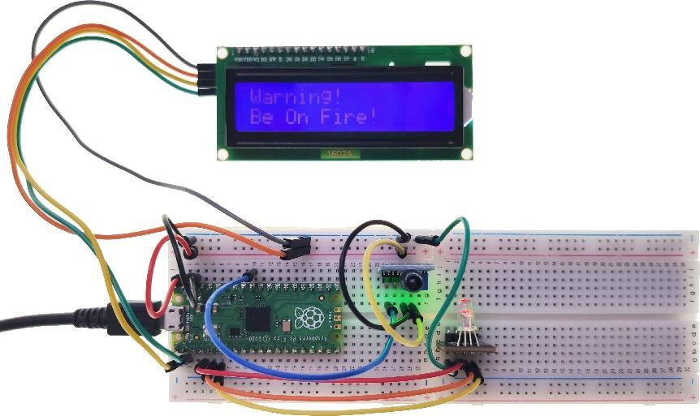

3.Circuit connection:
3.1 Material preparation: Raspberry Pi Pico*1, USB cable*1, Breadboard*2, *1, LCD1602*1, RGB LED*1, Dupont line;
3.2 Port connection:
Raspberry Pi Pico | Flame sensor
GND | GND
VSYS | VCC
-- | DO
GP26(ADC0) | AO

Raspberry Pi Pico | LCD1602
GP0 | SDA
GP1 | SCL
VSYS | VCC ( + )
GND | GND ( - )

Raspberry Pi Pico | RGB LED
GND | GND
GP4 | R
GP3 | G
GP2 | B

4.Library file installation:
Upload the “i2c_lcd.py” and “i2c_api.py” library file to the Raspberry Pi Pico. For the specific operation steps, please refer to Lesson 16.

5.Program analysis: Alarm of Fire
from machine import Pin,ADC,PWM,I2C
from i2c_lcd import I2cLcd
from time import sleep

DEFAULT_I2C_ADDR = 0x27 # LCD 1602 I2C address
# If 0x27 doesn't respond then 0x3f is used
Flame_AO = ADC(0) # ADC0 multiplexing pin is GP26

Led_R = PWM(Pin(4))
Led_G = PWM(Pin(3))
Led_B = PWM(Pin(2))
Led_R.freq(2000) # Set the frequency to 2KHz
Led_G.freq(2000)
Led_B.freq(2000)

i2c = I2C(0,sda=Pin(0),scl=Pin(1),freq=400000)
lcd = I2cLcd(i2c, DEFAULT_I2C_ADDR, 2, 16)

If __name__ == ‘__main__’:
while True:
text = 'Warning!\nBe On Fire!' # show alert information
Flame_value = Flame_AO.read_u16() # Get the analog value of the flame sensor
if Flame_value < 30000:
lcd.putstr(text)
Led_R.duty_u16(65535)
Led_G.duty_u16(0)
Led_B.duty_u16(0)
sleep(0.5)
lcd.clear()
Led_R.duty_u16(0)
Led_G.duty_u16(0)
Led_B.duty_u16(65535)
sleep(0.5)
else:
Led_R.duty_u16(0)
Led_G.duty_u16(65535)
Led_B.duty_u16(0)

